MEASUREMENT PROBLEMS
KS1 – 2001 Paper
1.
350 (milliliters)

KS1 – 2005 Paper 1
2.
Make measurement

KS1 – 2005 Paper 2
3.
a. 125m
b. 9 lengths

KS1 – 2007 Paper 2
4.
KS1 – 2009 Paper 1
5.
KS1 – 2009 Paper 2
6.
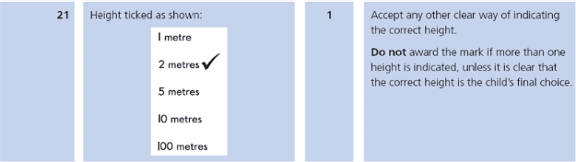
KS1 – 2016 Paper - Reasoning
7.
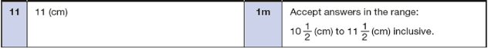
KS1 – 2017 Paper – Reasoning
8.
